Design document: poll app

# Domain model

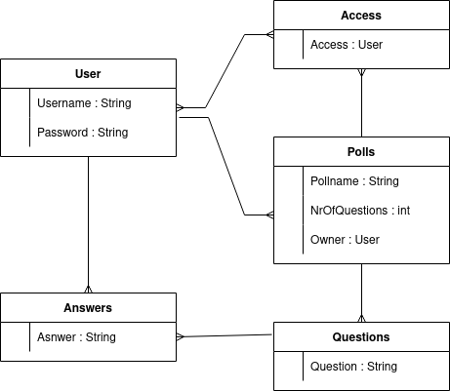

The app needs to store the following items:

* User: A registered user for the website
* Polls: Polls created by a user
* Questions: Questions in a poll
* Answers: Answers by users to a given question
* Access: Which users have access to which poll

# Use case

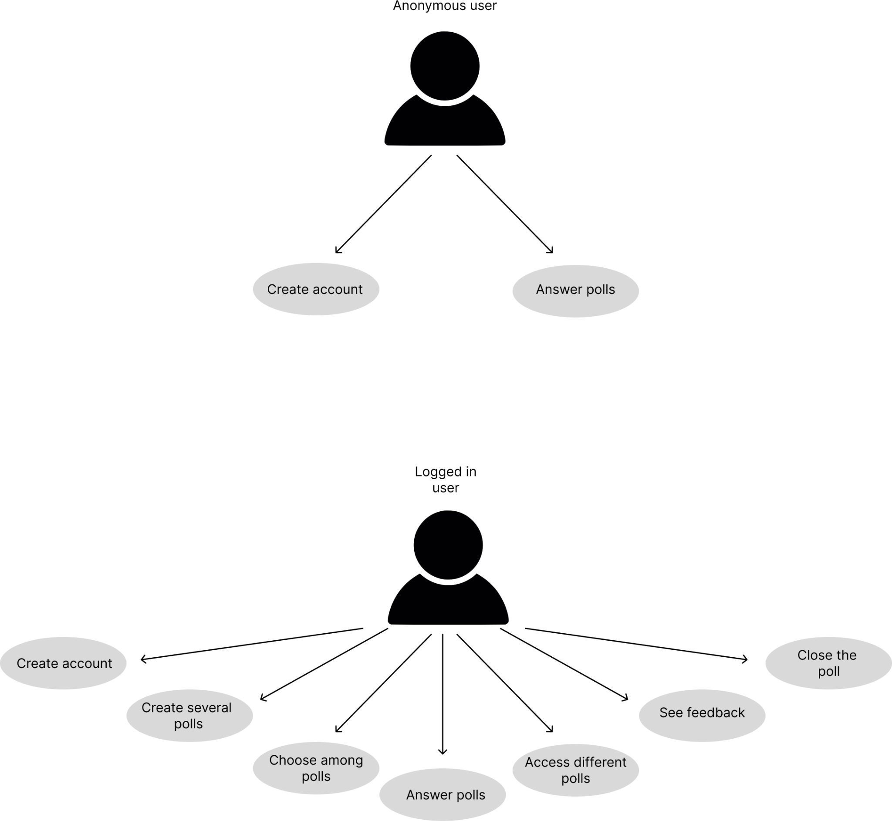

We keep a distinction between two types of users:

* Anonymous users can:
  + Answer polls if login is not required
  + Create an account
* Logged in users can in addition:
  + Answer polls if accessible to user
  + Create new polls
  + See results of own polls

# Application flow (front-end)

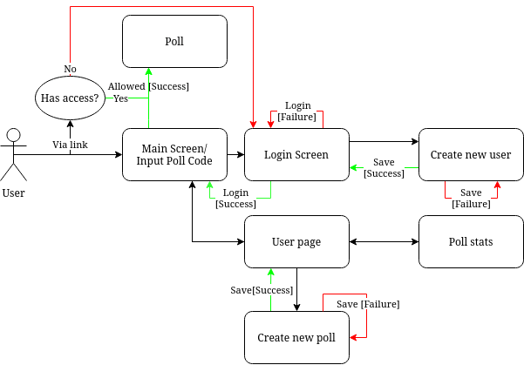

Pages available to users:

* Main - First page when entering. Able to enter poll code or login to user
* Poll - A poll created by the user containing questions
* Login screen - Ability to enter username and password or create a new account.
* Create new user - Create a new user.
* User page - Page containing a logged in users created polls.
* Poll stats - The results of a poll.
* Create new poll - Page for creating and configuring new polls.

# Mock up

# Architectural diagram

